Name : Ghadge Dhanshri Prakash

Subject: Web Supporting Technology

Roll No:12

PRN NO:2421100256

# ASSIGNMENT NO:1

**Q.1 Admission**

<!Doctype html>

<html>

<head>

<title> Admission section</title>

<style> .bvdu{ display:flex; justify-content:left; align-item:left;

margin:0 050px 0;

}

h1{ text-align:center; font-size:45px;

}

.ymim{

display:flex; justify-content:right; align-item:right; margin:0 050px 0;

}

.logo img{

height:50vh;

display:flex; justify-content:center; align-item:center;

}

marquee{ background-color:green; font_size:bold; color:white; font-size:40px;

}

</style>

</head>

<body>

<div class="bvdu">

<img src="C:\Users\admin\Desktop\wst lab\download.logo.jpg">

<span><h1>Bharati Vidyapeeth University<br> Yashwantrao mohite institute of management karad, malkapur</h1></span>

<div class="ymim">

<img src="C:\Users\admin\Desktop\wst lab\download.logo.jpg">

</div>

</div>

</body>

<hr>

<frameset cols="50%,50%">

<frame src="https://www.javatpoint.com/html-table">

<frame src="https://www.javatpoint.com/css-table">

</frameset> <center>

<div class="logo">

<a href="C:\ymim\cettable.html">

<img src="C:\Users\admin\Desktop\new.logo.webp">

</div>

<marquee direction="right" direction="left" scrollamount="20">Admission open 2025 click here..</marquee>

</center>

</body>

</html>

**OUTPUT:**

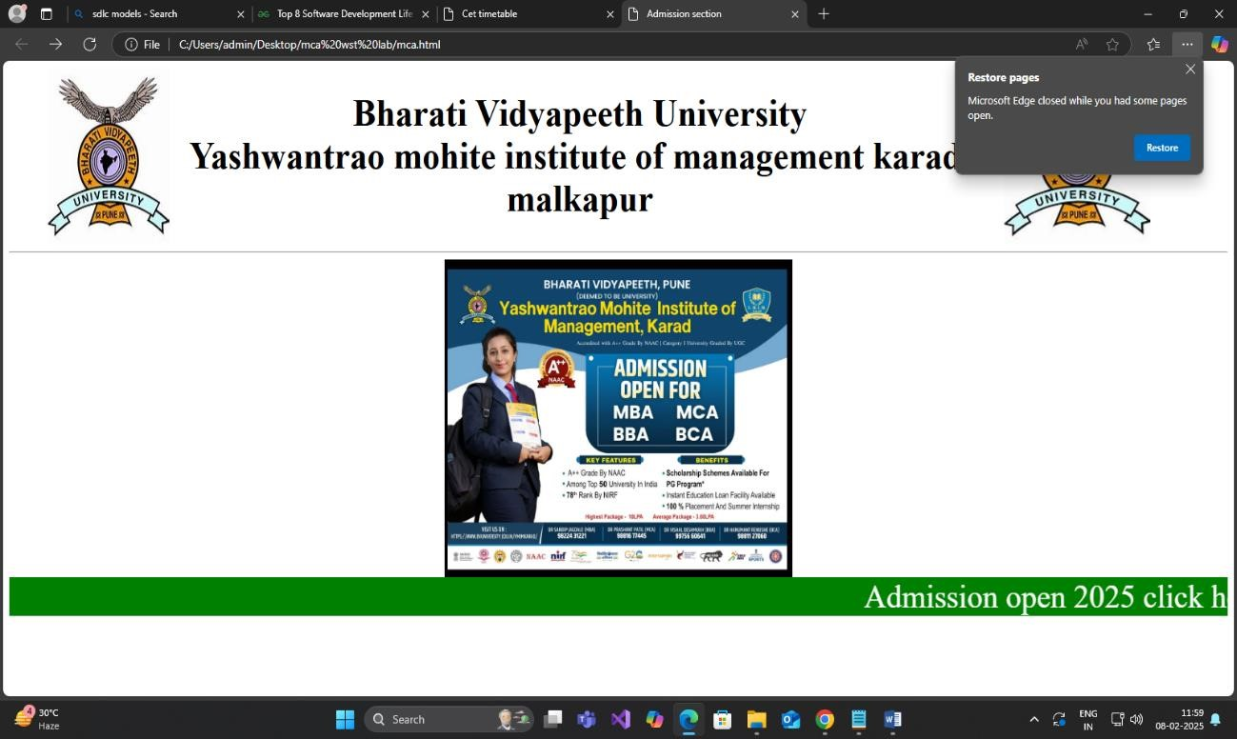

**Cet table code here..**

<!Doctype html>

<html>

<head>

<title>Cet timetable</title>

<style> table{ text-align:center; font-size:40px;

}

.bvdu{ display:flex; justify-content:left; align-item:left;

}

h2{ text-align:center; font-size:50px;

}

.ymim{

display:flex; justify-content:right; align-item:right;

</style>

</head>

<body>

<center>

<div class="bvdu">

<img src="C:\Users\admin\Downloads\bvdu.logo.jpg"> <span><h2>Bharati Vidyapeeth University<br> Yashwantrao mohite institute of management karad, malkapur</h2></span>

<div class="ymim">

<img src="C:\Users\admin\Downloads\bvdu.logo.jpg">

</div>

</div>

<hr>

<table border=1>

<tr>

<th>Course</th>

<th>Date of Entrance</th>

<th>CET Fees</th>

</tr>

<tr>

<td>MCA</td>

<td>12/7/2025</td>

<td>2500</td>

</tr>

<tr>

<td>MBA</td>

<td>12/7/2025</td>

<td>2500</td>

</tr>

<tr>

<td>BCA</td>

<td>20/7/2025</td>

<td>1200</td>

</tr>

<tr>

<td>BBA</td>

<td>20/7/2025</td>

<td>1200</td>

</tr>

</center>

</html>

**OUTPUT:**

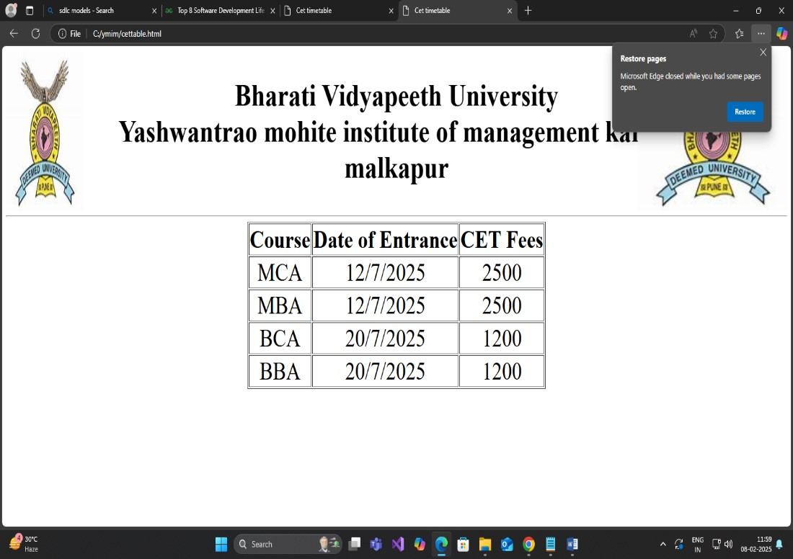

Name : Ghadge Dhanshri Prakash

Subject: Web Supporting Technology

Roll No:12

PRN NO:2421100256

Assignment no:2

## Q.2 Frameset

<!DOCTYPE html>

<html>

<head>

<title>Frame tag</title>

</head>

<frameset cols="50%,50%">

<frame src="https://www.javatpoint.com/html-table"> <frame src="https://www.javatpoint.com/css-table">

</frameset>

</html>

**OUTPUT:**

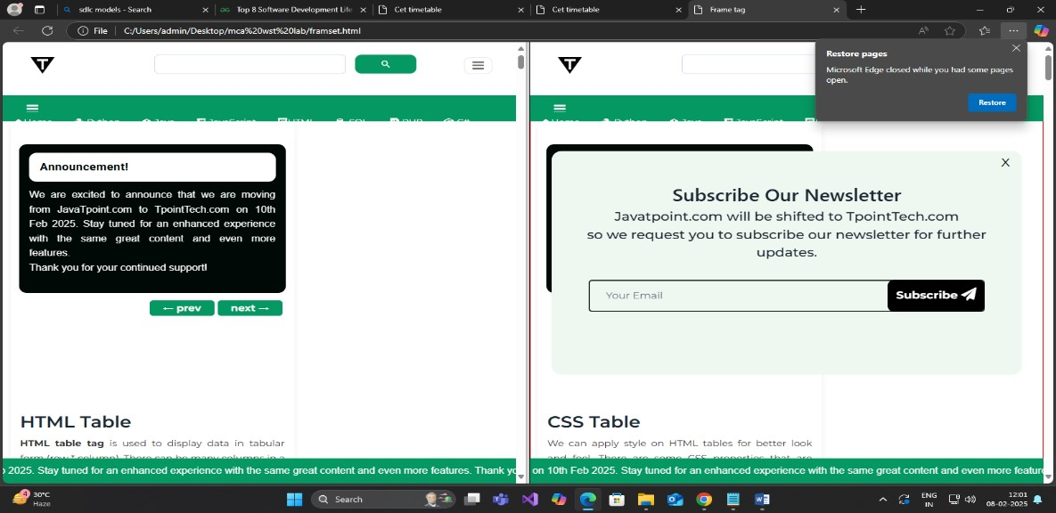

Name : Ghadge Dhanshri Prakash

Subject: Web Supporting Technology

Roll No:12

PRN NO:2421100256

# ASSIGNMENT NO:3

**Q.3.Ordered and unordered list.**

<!DOCTYPE html>

<html lang="en">

<head>

<meta charset="UTF-8">

<meta name="viewport" content="width=device-width, initial-scale=1.0">

<title>List</title>

<style> h1{ text-align:center;

} h2{ font-family: 'Courier New', Courier, monospace;

} ul{

color:blue;

} dt{ color:crimson;

}

</style>

</head>

<body>

<h1>MCA Programme</h1>

<hr align="left" width="100%" size="4" color="purple"> <h2>Subjects name:Web Supporting technologies</h2>

<hr align="left" width="100%" size="2" color="purple">

<ol type="I">

<li>Introduction to the internet</li>

<ul type="square">

<li>interanet</li> <li>introduction to web</li>

<li></li>

</ul>

<li>Html,css javascript</li>

<ul type="square">

<li>intro html</li>

<li>intro javascript</li>

</ul>

</ol>

<hr align="left" width="100%" size="2 " color="purple">

<h2>Subject name:Python</h1>

<hr align="left" width="100%" size="2" color="purple">

<ol type="I">

<li>python</li>

<ul type="square">

<li>datatypes</li>

<li>list</li>

</ul>

<li>Introduction to string</li>

<ul type="square">

<li>Typecasting</li>

<li>append,pop,remove</li>

</ul></ol><br>

<hr align="left" width="100%" size="4" color="purple">

<dl>

<dt><b>introduction to web programming</b></dt> <dd>internet is a web supporting technology that will be publically accessed in world wide</dd>

</dl>

</body>

</html>

**OUTPUT:**

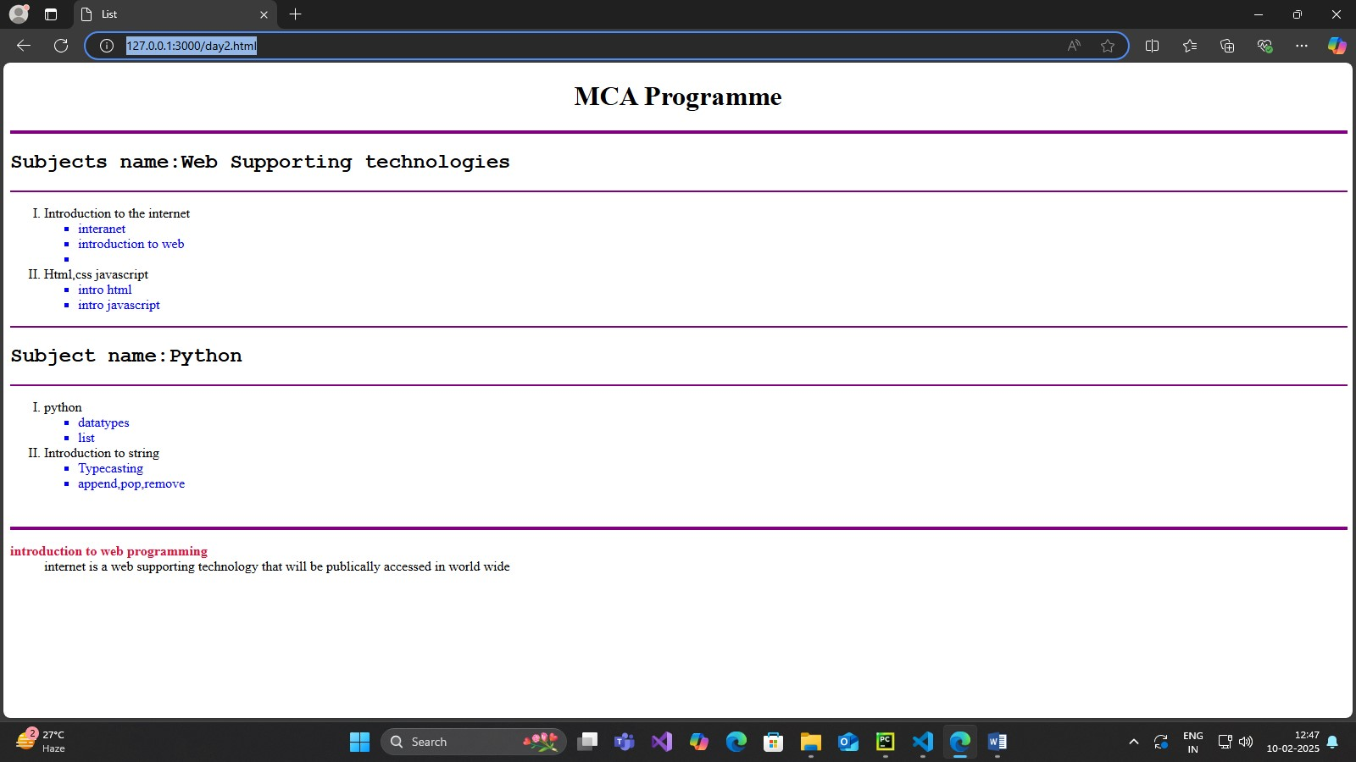

Name : Ghadge Dhanshri Prakash

Subject: Web Supporting Technology

Roll No:12

PRN NO:2421100256

# ASSIGNMENT NO:4

## Q.4.Audio and Vedio

<!DOCTYPE html>

<html lang="en">

<head>

<meta charset="UTF-8">

<meta name="viewport" content="width=device-width, initial-scale=1.0">

<title>Audio and Video Example</title>

</head>

<body>

<h1>HTML5 Audio and Video Example</h1>

<!-- Audio -->

<h2>Audio Example</h2>

<audio controls> <source

src="https://www.bing.com/ck/a?!&&p=322f77a411e9acab8c508a3dee5a9ac7476ce0

9009153e8ea6d9c84b58ff7ca7JmltdHM9MTczOTA1OTIwMA&ptn=3&ver=2&hsh=4&fclid=1 63a01ac-ebf5-693a-109c-

12f7ea6e680d&psq=kase+sartil+saye+song&u=a1aHR0cHM6Ly9nZWV0bWFuanVzaGEuY29 tL2x5cmljcy84NzcyLWthc2Utc2FydGlsLXNheWUtbWF6eWEtdmluYS1kaXMtdHV6ZS0lRTAlQ TQlOTUlRTAlQTQlQjglRTAlQTUlODctJUUwJUE0JUI4JUUwJUE0JUIwJUUwJUE0JUE0JUUwJUE 1JTgwJUUwJUE0JUIyLSVFMCVBNCVCOCVFMCVBNCVBRiVFMCVBNSU4Ny0lRTAlQTQlQUUlRTAlQ TQlQkUlRTAlQTQlOUQlRTAlQTUlOEQlRTAlQTQlQUYlRTAlQTQlQkUlRTAlQTQlQjUlRTAlQTU lODAlRTAlQTQlQTglRTAlQTQlQkUtJUUwJUE0JUE2JUUwJUE0JUJG&ntb=1" type="audio/mpeg">

Your browser does not support the audio element.

</audio>

<!-- Video -->

<h2>Video Example</h2>

<video width="320" height="240" controls>

<source src="" type="video/mp4">

Your browser does not support the video tag.

</video>

</body>

</html>

**OUTPUT:**

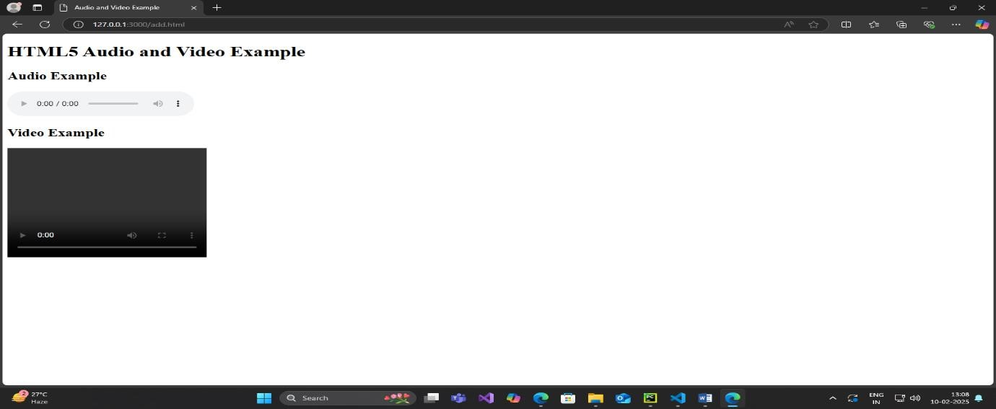

Name : Ghadge Dhanshri Prakash

Subject: Web Supporting Technology

Roll No:12

PRN NO:2421100256

# ASSIGNMENT NO:5

## Q.5 Time Table

<!Doctype>

<html>

<head>

<title>Time table</title>

<style> body{

background-color:lightgrey

} h2{ text-align:center; color:red

} h3{ text-align:center; color:green } table{ text-align:center;

} th{ background-color:lightSalmon

} td{

background-color:lightPink

}

</style>

</head>

<body>

<h2>BHARATI VIDYAPEETH TO BE UNIVERSITY,PUNE<br> YASHWANTRAO MOHITE INSTITUTE OF MANAGEMENT KARAD<h2>

<h3>ACADEMIC YEAR 2024-25<br> MCA-I SEM-II(2024-25)</h3>

<hr>

<h3 style="color:red">Time Table<h3>

<center>

<table border=1>

<tr>

<th></th>

<th>MON</th>

<th>TUE</th>

<th>WED</th>

<th>THU</th>

<th>FRI</th>

<th>SAT</th>

<th>Lecture hall/Lab</th>

</tr>

<tr>

<td>10:30-11:30PM</td>

<td>CC<br>[ppp]</td>

<td>CC<br>[ppp]</td>

<td>CC<br>[ppp]</td>

<td>PYTHON<br>[AS]</td>

<td>PYTHON<br>[AS]</td>

<td>PYTHON<br>[AS]</td>

<td>Multi</td>

</tr>

<tr>

<td>11:30-12:30PM</td>

<td>PYTHON-Lab<br>[AS]</td>

<td>PYTHON-Lab<br>[AS]</td>

<td>PYTHON-Lab<br>[AS]</td>

<td>WST Lab<br>[AAP]</td>

<td>WST Lab<br>[AAP]</td>

<td>WST Lab<br>[AAP]</td>

<td>Lab-3</td>

</tr>

<tr>

<td>12:30-1:30PM</td>

<td>WST<br>[AJ]</td>

<td>WST<br>[AJ]</td>

<td>WST<br>[AJ]</td>

<td>OOSE<br>[PRR]</td>

<td>OOSE<br>[PRR]</td>

<td>OOSE<br>[PRR]</td>

<td>Lab-3</td>

</tr>

<tr>

<td>1:30-2:00PM</td>

<th colspan="7">BREAK</th>

</tr>

<tr>

<td>2:00-3:00</td>

<td>DWDM<br>[SVD]</td>

<td>DWDM<br>[SVD]</td>

<td>DWDM<br>[SVD]</td>

<td>DT<br>[PRR]</td>

<td>DT<br>[PRR]</td>

<td>DWDM<br>[SVD]</td>

<td>Lab-3</td>

</tr>

</table>

<br>

<table border=1>

<tr>

<th>SR.NO</th>

<th></th>

<th>Subject Name</th>

<th>Faculty Name</th>

</tr>

<tr>

<td>201</td>

<td><a href="C:\Users\Admin\Desktop\Notes\OOSE.pdf">OOSE</a></td>

<td>Object Oriented Software Engineering</td>

<td>Prof.P.R.Rasal</td>

</tr>

<tr>

<td>202</td>

<td><a href="C:\Users\Admin\Desktop\Notes\CC.pdf">CC</td>

<td>Cloud Computing Concepts</td>

<td>Dr.P.P.Patil<br><b>Class Coordinator</b></td>

</tr>

<tr>

<td>203</td>

<td><a href="C:\Users\Admin\Desktop\Notes\PYTHON.pdf">DS</td>

<td>Data Structure using Python</td>

<td>Mrs.Ashwini Sarate</td>

</tr>

<tr>

<td>204</td>

<td><a href="C:\Users\Admin\Desktop\Notes\DWDM.pdf">DWDM</td>

<td>Data Warehouse and Data Minig</td>

<td>Dr.Mrs.Sheetal Deshmukh</td>

</tr>

<tr>

<td>205</td>

<td><a href="C:\Users\Admin\Desktop\Notes\WST.pdf">WST</td>

<td>Web Supporting Technologies</td>

<td>Mrs.Archana Jadhav </td>

</tr>

<tr>

<td>206</td>

<td><a href="C:\Users\Admin\Desktop\Notes\python lab.pdf">Lab on DS</td>

<td>Lab on Data Structure using Python</td>

<td>Mrs.Ashwini Sarate</td>

</tr>

<tr>

<td>207</td>

<td></td>

<td>Minor Project-I</td>

<td>Dr.P.P.Patil</td>

</tr>

<tr>

<td>208<br><hr>209</td>

<td></td>

<td>MOOCS-II*<br><br><a href="C:\Users\Admin\Desktop\Notes\Digiital

Technology.pdf">Open Courde-II**-Digital <br>Technology</td>

<td>Dr.P.P.Patil<hr>Prof.P.R.Rasal</td>

</tr>

</table>

</center>

</body>

</html>

**OUTPUT:**

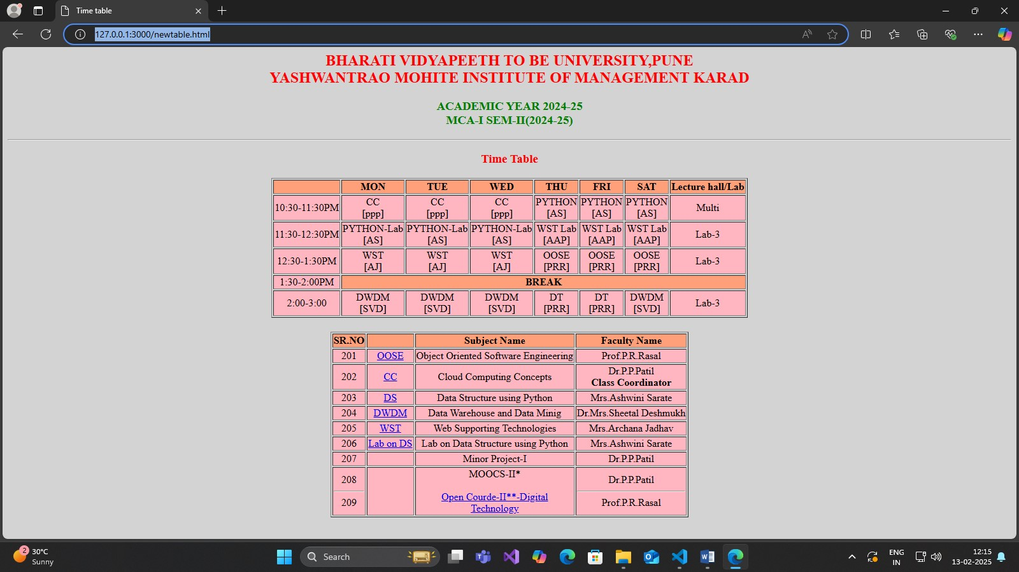

Name : Ghadge Dhanshri Prakash

Subject: Web Supporting Technology

Roll No:12

PRN NO:2421100256

## ASSIGNMENT NO:6

### Q.6.Student registration form

<!DOCTYPE html>

<html lang="en">

<head>

<meta charset="UTF-8">

<meta name="viewport" content="width=, initial-scale=1.0">

<title>Document</title>

</head>

<body><center></center><h1>YASHWANTRAO MOHITE INSTITUTE OF MANAGEMENT

KARAD,MLAKAPUR</h1>

<H2>Student Registration form</H2></body></center>

<form action="">

<label for="">First Name:</label>

<input type="text" required>

<br>

<br>

<label for="">Middle Name:</label>

<input type="text" required>

<br>

<br>

<label for="">Last Name:</label>

<input type="text">

<br>

<br>

<label for="gender">gender</label>

<input type=radio name="gender id="">male

<input type=radio name="gender id="">female

<input type=radio name="gender id="">other

<br><br>

<label form="dob">DOB</label>

<input type="date" name="" id="">

<br><br>

<label for="address">address</label>

<textarea name="" id=""></textarea>

<br><br>

<label for="mobile no">Mobile No:</label>

<input type=tel>

<br>

<br>

<label for="">Email id:</label>

<input type="text" required>

<br>

<br>

<label for="department">Department</label>

<select name="" id="">

<option value="">select</option>

<option value="">computer</option>

<option value="">Management</option>

</select>

<br>

<br>

<label for="course">Course</label>

<select name="" id="">

<option value="">select</option>

<option value="">MCA</option>

<option value="">MBA</option>

<option value="">BCA</option>

<option value="">BBA</option>

</select>

<br>

<br>

<label for="subject">Subject</label>

<br>

<input type="checkbox" name="" id="">Computer network<br>

<input type="checkbox" name="" id="">Java<br>

<input type="checkbox" name="" id="">C programming<br>

<input type="checkbox" name="" id="">Python<br><br>

<button type="submit">Submit</button>

<button type="reset">Reset</button>

<button type="exit">Exit</button>

</form>

</body>

</html>

**OUTPUT:**

